Skin Graph-t 6/23/15

Tech Writer: Mitchell Mikinski

Engineer: Dean Gladish

Conductor: Dean Gladish

Reporter: Charlie Goldschmiedt

Nice job on this problem set! I was particularly impressed with your use of examples, and exploring lots of cases. “Playing” with math is always good! Try to explain your proofs more carefully and thoroughly, and be sure you’re not making any big assumptions or logical leaps.--RK

We are proud of what we were able to accomplish on questions 2 and 3.

Morning Report: In the morning we played the game Cutthroat on the Petersen graph, in which two players alternate turns with the objective of being the last player to delete a vertex. We then tried to ascertain whether the first or second player would win depending on a number of odd and even stars. Nice summary.--RK

Afternoon Report: In the afternoon we cooperated, and communicated well. We had difficulty on question 5 part C, and didnt even get to part D. We did as much as we could up to Part C in question 5. We didn’t have enough time to do any other questions after 5. Overall the evening was successful and stressless. Sounds good! As long as you’re working on the problems, it’s okay not to finish everything.--RK

1. Given that there is an odd number of odd number of odd numbered stars, the degree sum (This isn’t technically the degree sum, but I know what you mean.) would equal an odd number. This would result in a victory for N. Given this information, the contrapositive is true as well, if the result is not an odd numbered degree sum, then N would not win. Therefore, declaring P victorious in the case of an even numbered degree sum. Be careful! Did you state the contrapositive or the converse? Also, I don’t think don’t think looking at the “degree sum” is enough here. For example, the game with 1 2-star and the game with 2 1-stars both give a sum of 2, but they have different outcomes--can you see why?--RK

P Wins

|  |  |  |
| --- | --- | --- |
| Beginning | 5 | 7 |
| N | 4 | 7 |
| P | 4 | 6 |
| N | 3 | 6 |
| P | 3 | 5 |
| N | 2 | 5 |
| P | 2 | 4 |
| N | 1 | 4 |
| P | 1 | 3 |
| N | 0 | 3 |
| P | 0 | 0 |

2) Given that G is isomorphic to H, meaning that they are mathematically equivalent, we can say that G is mathematically equivalent to H. H is given as isomorphic, and therefore equivalent to J. Therefore, G is isomorphic to J by the transitive property.

I see what you’re getting at here; the statement that “if G is isomorphic to H, and H is isomorphic to J, then G is isomorphic to J” should hold for any reasonable definition of “isomorphic.” Maybe a better question would be “can we should that the definition of isomorphism in terms of labeling has this property, which we would expect from any ‘good’ definition of isomorphism?”  
Can you make a concrete argument using labelings of the graphs G, H and J?--RK

3) Since the graph of Kn would by definition require each vertex to be connected to every other vertex, we would use the value “N-1” as the value for the degree of each vertex. We would multiply this value by n because n is the number of vertices in the graph; in order to calculate the degree sum: n*(N-1). The degree sum N*(N-1)= 2* M(size of graph). Dividing by 2 gives the value for M: (N(N-1))/2.

Good job including what we used in class yesterday to solve this problem, your solution is good. - Lizzy

4)

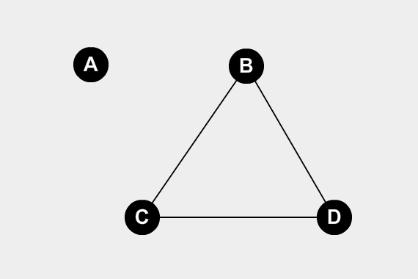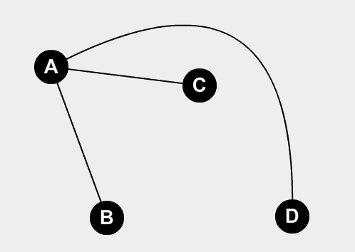Complement

Any disconnected vertices will be connected in the complement, because that is the definition of a complement.

An example is only useful if there are no possible counterexamples. Please use a proof next time with your answer. - Lizzy

b. Is the converse is true?

5) a. 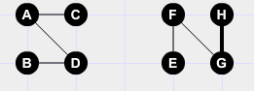

b. 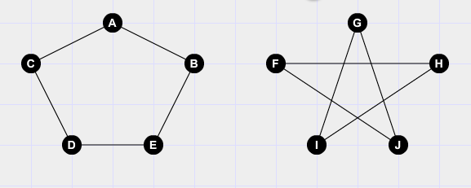

Please include explanations with your pictures. Its is not enough to just have a graph without explaining your graphs. You wouldn't use a resource in a paper without explaining why you used it, we know what the graphs represent, but we want to know if you do. - Lizzy

7) There is a cycle, which means that it is even-degreed.

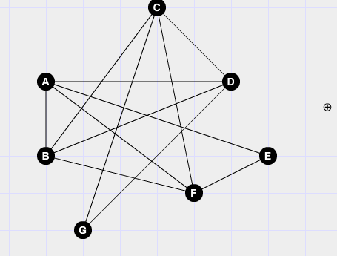Original

Remove the cycle A,B,F,E:

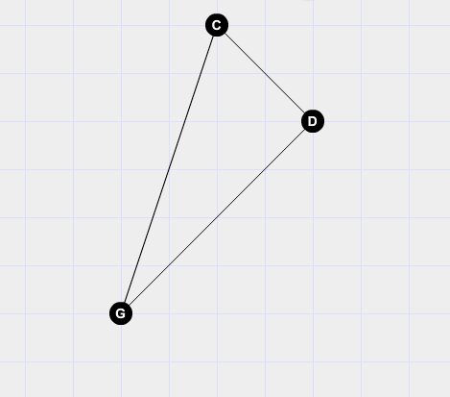

The resulting graph has a closed Eulerian Trail and is connected. This would also make a Hamiltonian Graph, as each vertex is used in a cycle with no cut vertices.

I am impressed with the way that you answered this question. Your approach to this question is very intelligent, and undoubtedly proves that your answer is correct, and a quicker way to do so than simply drawing out a path. Good job. - Lizzy